**Project Report Template**

**1 INTROUCTDION**

**1.1 Overview**

Comprehensive analysis of financial performance involves a detailed examination of a company's financial data to evaluate its overall financial health, profitability, efficiency, and sustainability. The analysis typically involves reviewing financial statements such as income statements, balance sheets, and cash flow statements, as well as other financial data such as key performance indicators and ratios. Overall, a comprehensive analysis of financial performance is a valuable tool for evaluating a company's financial health and informing decision-making related to resource allocation, investment opportunities, and strategic planning. However, it's important to recognize the potential limitations and drawbacks of this approach and to supplement financial data with other information sources.

**1.2 Purpose**

The purpose of a comprehensive analysis of financial performance is to evaluate the financial health and performance of a company. This analysis is typically conducted by investors, financial analysts, and other stakeholders to gain insights into the company's financial condition, profitability, and growth prospects.A comprehensive financial analysis typically involves examining a range of financial data, including income statements, balance sheets, cash flow statements, and other financial metrics. The analysis can help stakeholders to identify trends, strengths, weaknesses, and opportunities for improvement in a company's financial performance.

**2 Problem Definition & Design Thinking**

**2.1 Empathy Map**

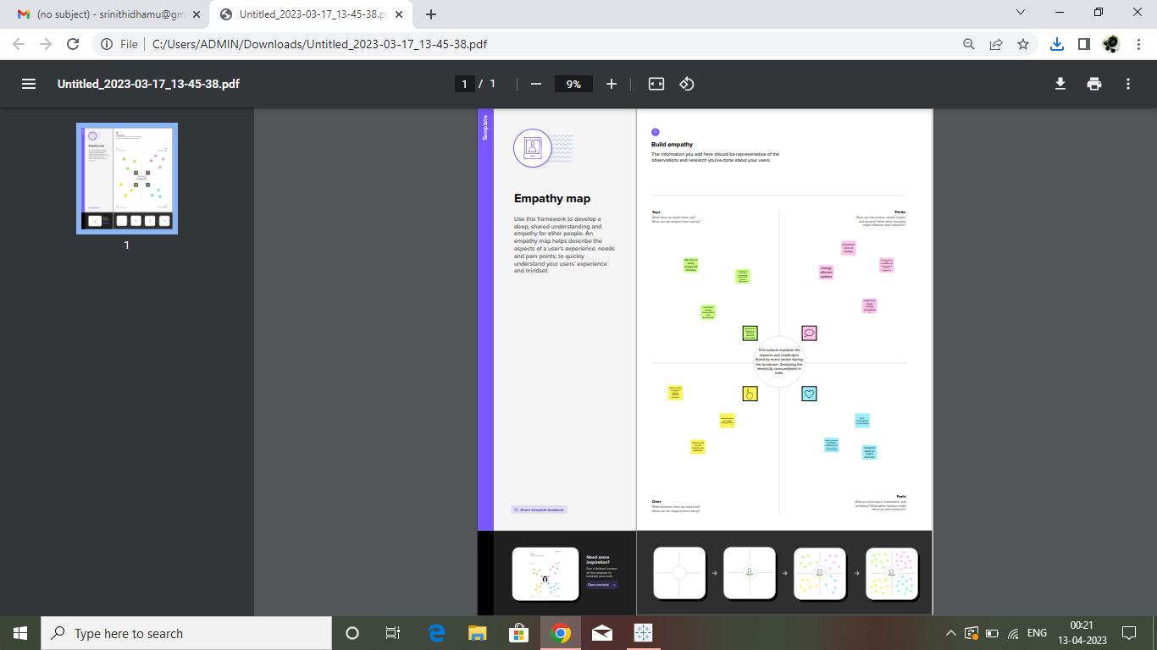

**2.2 Ideation & Brainstorming Map**

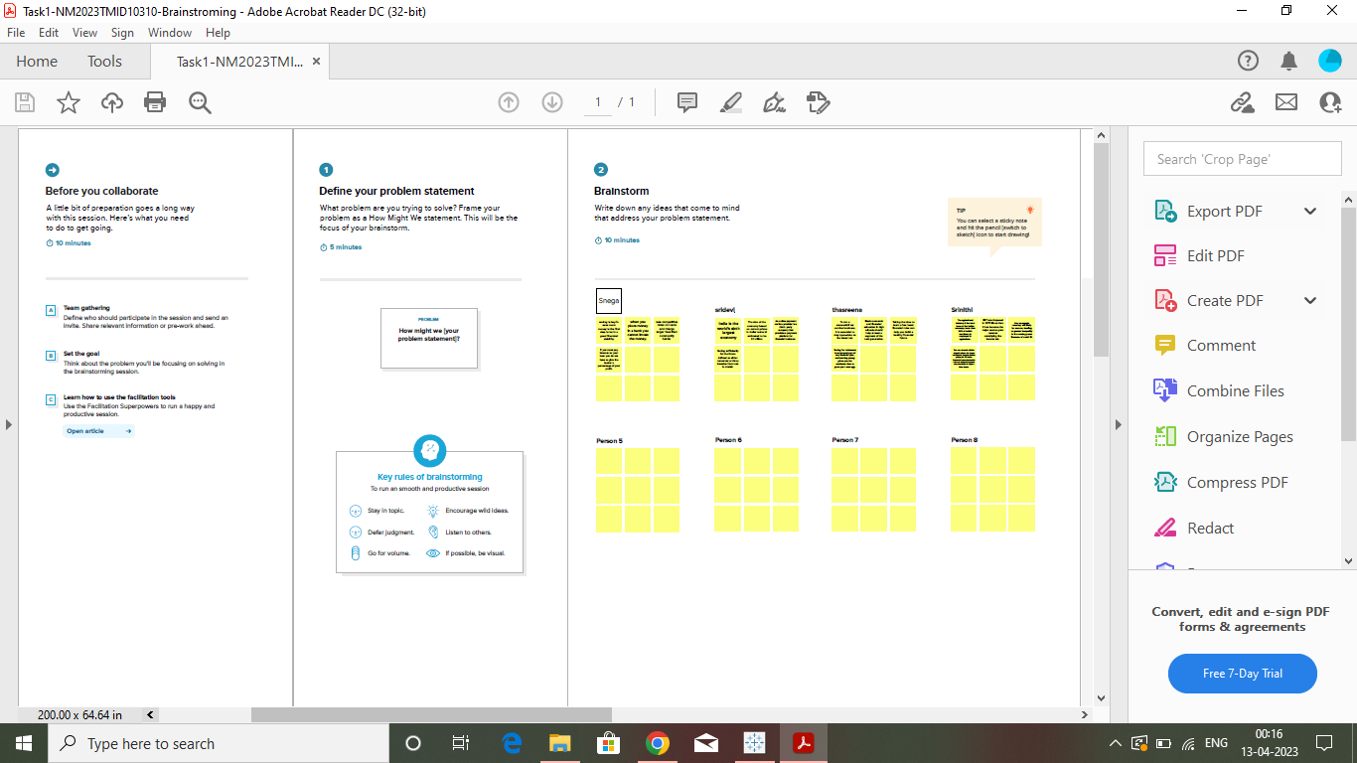

**3 RESULTS**

**3.1 Dashboard 1**

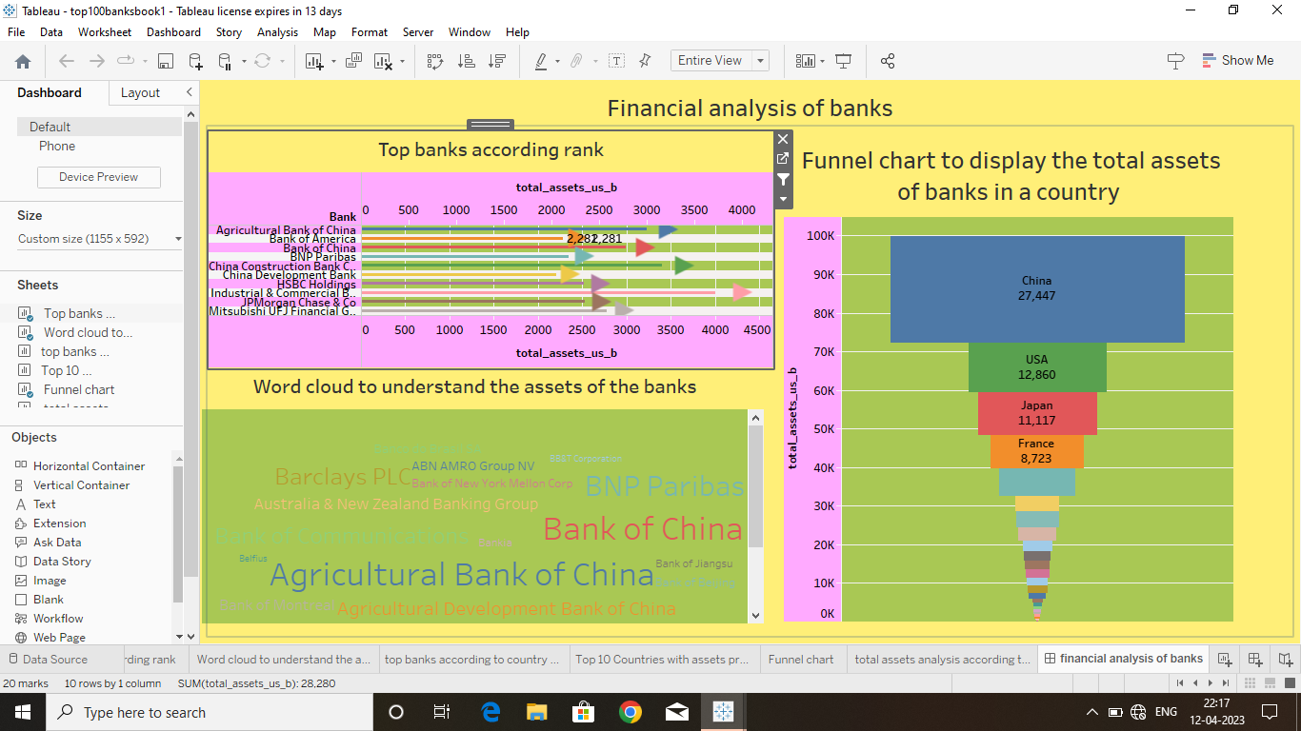

**3.2 Dashboard 2**

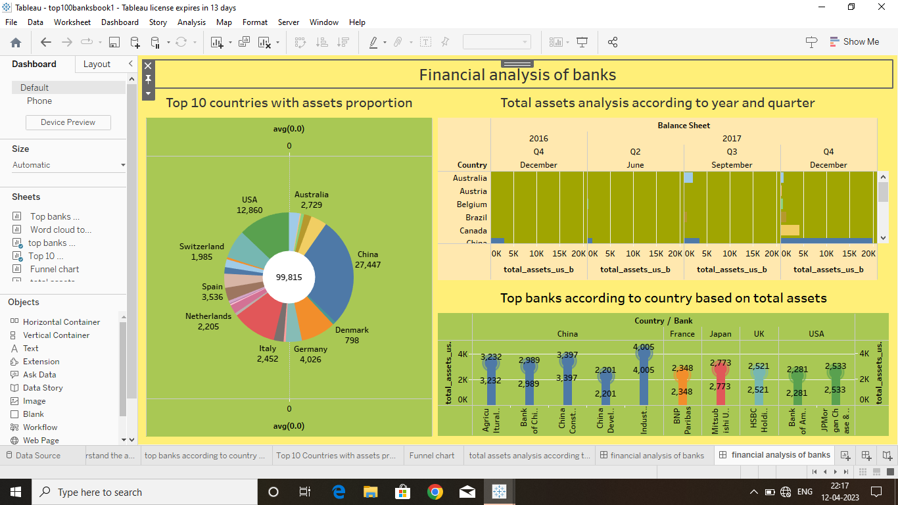

**3.3 html dashboard 1**

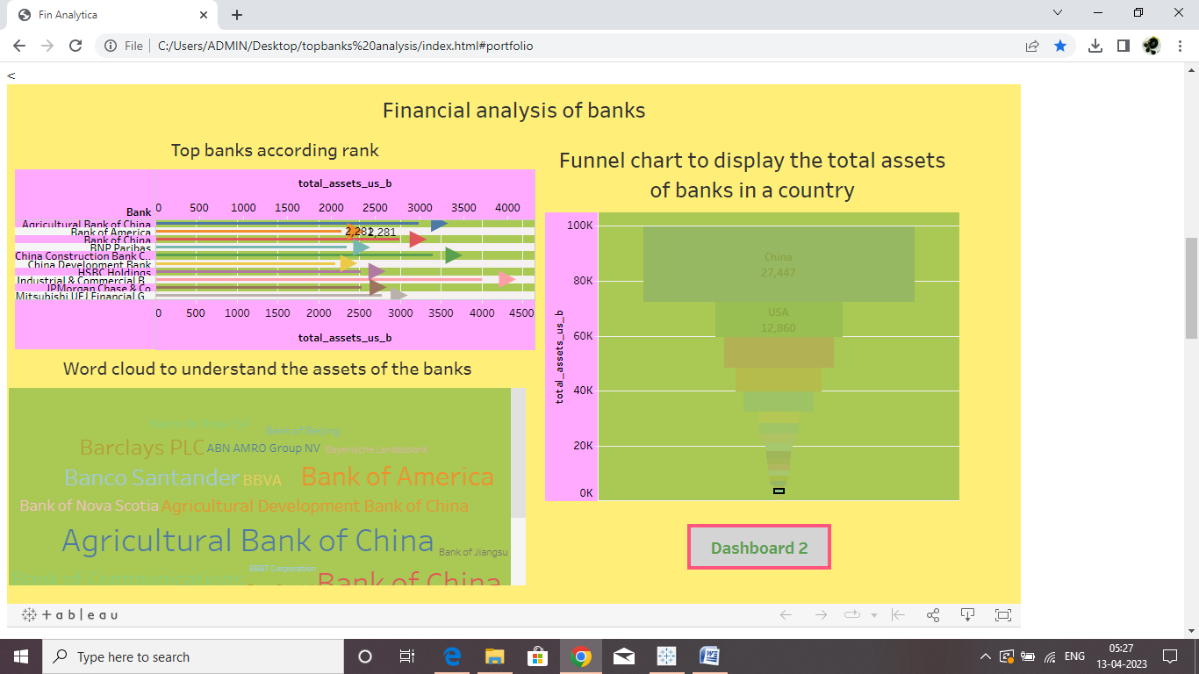

**3.4 html dashboard 2**

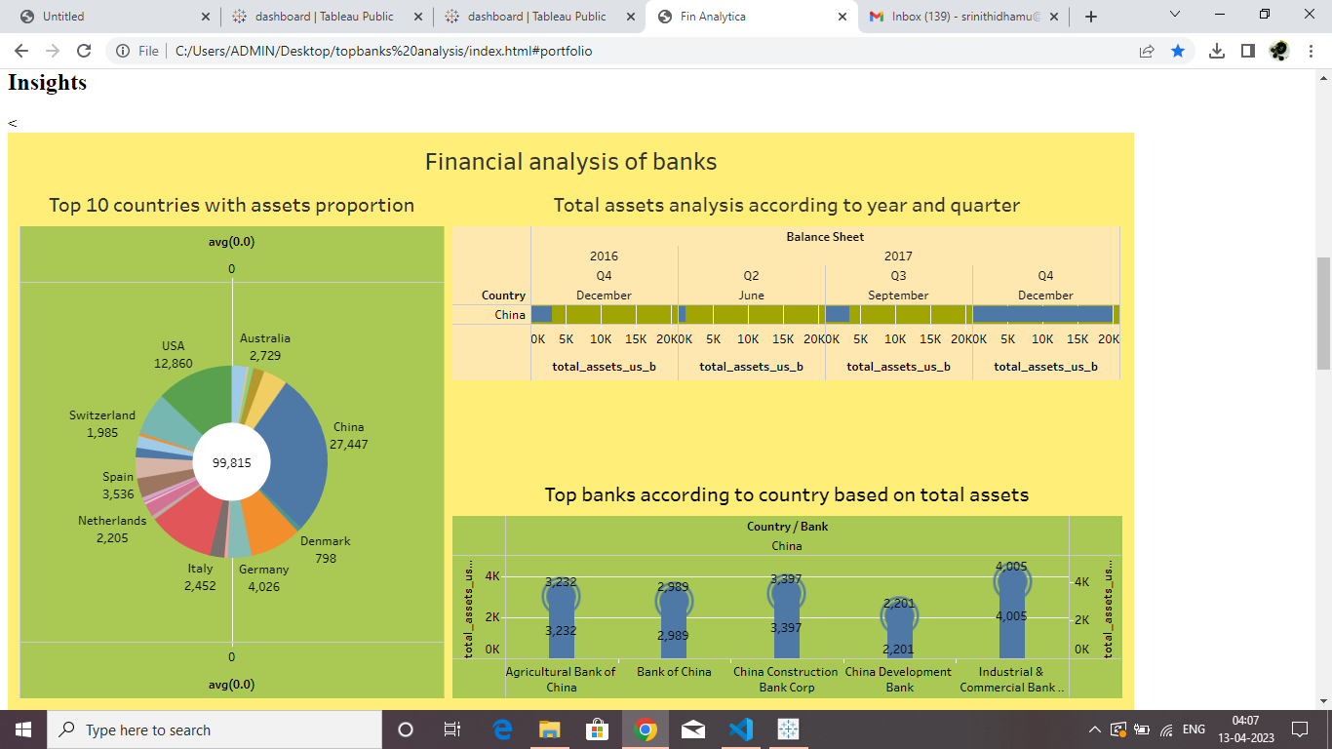

**3.5 html story**

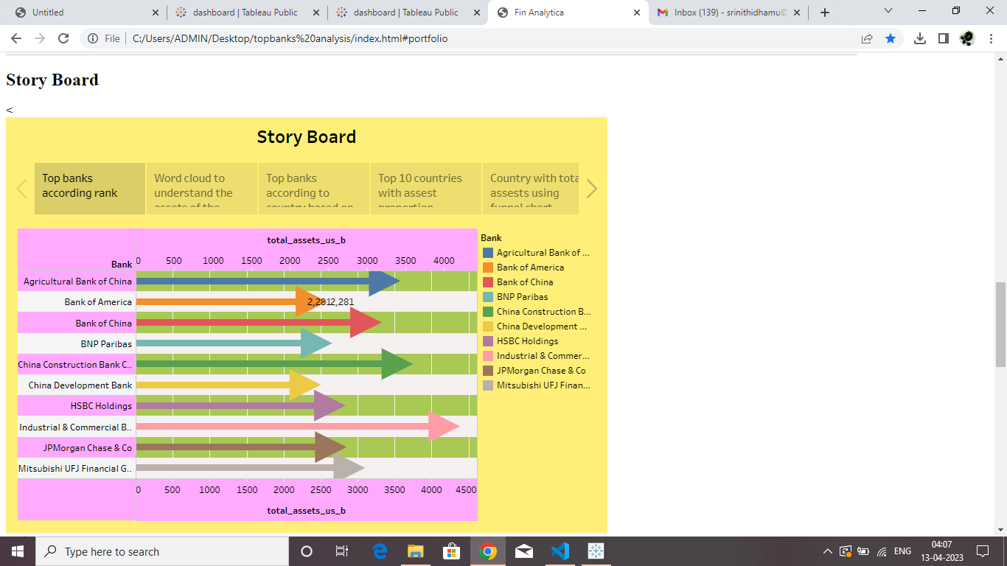

**4 ADVANTAGES & DISADVANTAGES**

**Advantages;**

A thorough analysis of financial performance can provide valuable insights into the financial health of a company, allowing decision-makers to make more informed choices about resource allocation, investment opportunities, and strategic direction.

Increased transparency: A comprehensive analysis of financial performance can help to increase transparency, making it easier for stakeholders to understand the company's financial position and performance. A thorough analysis of financial performance can help to identify trends and patterns in financial data, allowing for more accurate financial forecasting and planning.

Enhanced credibility: A comprehensive analysis of financial performance can help to build credibility with stakeholders, including investors, lenders, and regulators, by demonstrating a commitment to transparency and accountability.

**Disadvantages;**

Conducting a thorough analysis of financial performance can be time-consuming and require significant resources, including personnel and software tools.

Financial data can be complex and difficult to analyze, especially for those who are not trained in accounting or finance. This can make it challenging to interpret the results of a financial analysis and make informed decisions based on that information.

Financial data provides important information about a company's past performance, but it may not provide a complete picture of its future prospects. Other factors, such as market trends, customer behavior, and technological advancements, can also impact a company's performance.

**5 APPLICATIONS**

Tableau: Tableau is data visualization software that can be used for financial analysis. It offers the ability to create interactive dashboards and visualizations from financial data. When selecting an application for financial analysis, it's important to consider your specific needs and budget. Many applications offer free trials or demos, so you can test them out before committing to a purchase.

**6 CONCLUSION**

The conclusion of a comprehensive analysis of financial performance will depend on the specific company and its financial data. However, in general, a comprehensive analysis of financial performance should include an examination of a company's financial statements, including the balance sheet, total assets of bank, ranks based on a country and banks as well as an analysis of financial ratios. The conclusion may be that the company is financially strong and well-positioned for future growth, or it may identify areas where the company needs to make changes in order to improve its financial performance.

**7 FUTURE SCOPE**

Incorporating big data and advanced analytics: With the rise of big data, there is a wealth of information available that can be used to gain insights into financial performance. By using advanced analytics techniques such as machine learning and artificial intelligence, financial analysts can identify patterns, trends, and anomalies that would be difficult to spot through traditional methods.

Enhancing data visualization tools: In order to make financial analysis more accessible and understandable to a wider audience, there is a need for improved data visualization tools. This could involve creating interactive dashboards, using more sophisticated graphics and charts, or incorporating virtual or augmented reality to create more immersive experiences.

**8 APPENDIX**

1. **Source Code**
2. 